Bitcoin and Macro Variables
Correlation Analysis

Results

Version 1.0
11-10-2026

Table of contents
Summary 2
Methods 2
Results 3
Correlations with BTC 3
Lead-lag 4
Stability over time 4
Conclusions and Limitations 5

Summary
- BTC returns correlate moderately with risk assets and financial conditions: positively with equities (Russell 2000, S&P 500), high-yield bond ETFs and net liquidity, and negatively with the VIX, the dollar, credit spreads and tighter financial conditions (NFCI). The strongest correlations are 0.26 to 0.27 in absolute value at daily and weekly frequency and 0.37 (S&P 500) at monthly frequency; the leading variables in each panel have q < 0.05.
- No variable leads BTC: correlations peak at k = 0 and are close to zero for k > 0. None is related to the size of BTC's moves (q_abs of at least 0.22 among the 12 strongest variables of each panel).
- The relations are not stable: the S&P 500 correlation goes from near zero in 2017-2019 to 0.56 in 2022 and 0.44 in 2026.

Methods
- Data. BTC/USD minute data aggregated to daily, weekly and monthly log returns, starting on 2017-01-01, and about 40 macro and market variables from FRED and Yahoo Finance.
- Panels. Presented as log returns (rates and spreads as differences computed after aligning to the panel frequency). Slow series (e.g. CPI) only enter slower panels (monthly); the daily panel uses weekdays only.
- Redundancy. Variables with correlation above 0.85 with another macro variable were removed.
- Statistics. Spearman correlation with the BTC return and with the return’s absolute value; q-values from Benjamini-Hochberg false discovery rate correction.
- Lead-lag and stability. Lead-lag on an a-priori shortlist [SP500, DXY, US10Y, Gold, VIX, HY_OAS, NetLiquidity] (using availability-date alignment); stability check performed by sliding window.

Results
Sample: 2,550 daily (weekdays), 511 weekly and 117 monthly observations, from January 2017 to October 2026.
Variables kept after removing redundant ones:
- 24 in the daily panel
- 29 in the weekly
- 38 in the monthly.

Correlations with BTC
Table 1. Strongest Spearman correlations with the BTC return.
Frequency | Variable | n | r_ret | q_ret | r_abs | q_abs
Daily | Russell2000 | 2550 | 0.257 | <0.001 | -0.037 | 0.256
Daily | HY_OAS | 783(!) | -0.256 | <0.001 | -0.020 | 0.702
Daily | SP500 | 2550 | 0.236 | <0.001 | -0.037 | 0.256
Weekly | HY_OAS | 156(!) | -0.272 | 0.002 | 0.123 | 0.484
Weekly | Russell2000 | 511 | 0.257 | <0.001 | -0.046 | 0.625
Weekly | VIX | 511 | -0.231 | <0.001 | 0.057 | 0.486
Monthly | SP500 | 117 | 0.366 | 0.002 | 0.136 | 0.493
Monthly | NFCI | 117 | -0.322 | 0.008 | -0.027 | 0.893
Monthly | HYG | 117 | 0.287 | 0.017 | 0.103 | 0.706

The strongest relations are with risk assets and financial conditions. BTC returns move with equities and high-yield credit (Russell 2000, S&P 500, HYG) and against the VIX, the dollar and credit spreads (HY_OAS).
All the leading daily variables have q < 0.001, but the correlations are moderate. Weekly results are similar. In the monthly panel the S&P 500 is the strongest (r = 0.37, q = 0.002), followed by NFCI, HYG, net liquidity and Russell 2000, all with q < 0.05; the VIX (r = -0.23, q = 0.061) does not reach that level, and monthly results rest on only 117 observations. HY_OAS appears among the top rows of the daily and weekly tables but covers only the period since 2023 (783 and 156 observations), so it cannot be compared directly with the rest. No variable is related to the size of BTC's moves: among the 12 strongest variables of each panel, q_abs is at least 0.22 (low probability of correlation)

Lead-lag
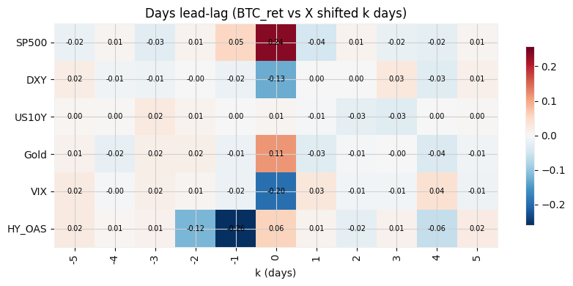
Figure 1. Daily lead-lag correlations (Spearman) between the BTC return and each variable shifted by k days, with availability-date alignment; k > 0 means the variable leads BTC.
At the daily frequency every variable peaks at k = 0 (S&P 500 0.24, VIX -0.20, DXY -0.13, Gold 0.11) and all values at k > 0 are within +/-0.06, so none of them leads BTC. HY_OAS peaks at k = -1 (-0.26): this is its same-day correlation, shifted by one position by its two-day publication lag, and it is close to zero at k = 0 (0.06). The weekly panel (not shown) gives the same picture: the strongest cells are at k = 0 (HY_OAS -0.27, S&P 500 0.23, VIX -0.23), and the largest cell with k > 0 is HY_OAS at k = 1 (-0.13, n = 156), which is below the 5% significance level for 156 observations even before correcting for the 63 cells tested.

Stability over time
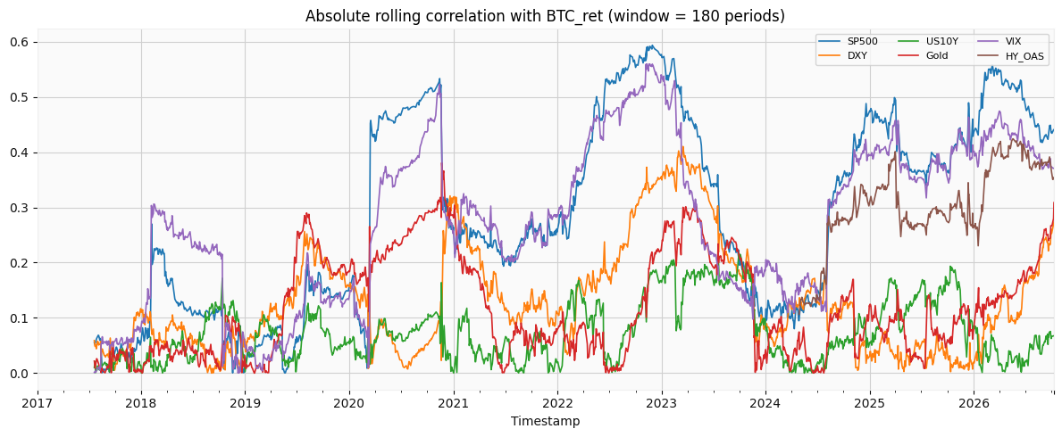
Figure 2. Rolling absolute correlation (Pearson, window of 180 daily observations) between the BTC return and the shortlisted variables.
The relations are not stable. The rolling correlation with the S&P 500 and the VIX, which move together, rises from low values (mostly below 0.2) in 2017-2019 to 0.4-0.6 in 2020 and 2022-2023, falls to about 0.1-0.2 in early 2024 and returns to 0.4-0.55 in 2025-2026. The yearly Spearman correlations confirm this: the S&P 500 goes from 0.04, 0.05 and -0.02 (2017-2019) to 0.56 in 2022 and 0.44 in 2026, with the opposite sign for the VIX (-0.49 in 2022); DXY is negative in most years (-0.32 in 2022), US10Y stays close to zero (-0.15 to 0.09), Gold is strong only in some years (0.31 in 2020, 0.33 in 2026) and HY_OAS, available since 2023, ranges from -0.17 to -0.34. The abrupt jumps in the rolling lines (for example in March 2020) are single extreme days entering or leaving the window, a known sensitivity of the Pearson correlation used in this plot. Drops in correlation for some variables coincide with rises in others (in late 2020 the S&P 500 falls from about 0.53 to 0.25 while DXY rises from about 0.1 to 0.3), but the S&P 500 and the VIX move together, so they largely reflect a single risk-appetite factor.

Conclusions and Limitations
Between 2017 and 2026, BTC returns co-move with global risk appetite: positively with equities, high-yield bond ETFs and net liquidity, and negatively with the VIX, the dollar, credit spreads and tighter financial conditions. The relations are moderate (|r| up to 0.26 daily and 0.37 monthly), stronger in some periods (2020-2023, 2025-2026) than in others, and contemporaneous: no variable leads BTC and none is related to the size of its moves. The evidence supports an association with risk appetite, not a predictive relation or a causal one.
- Correlation is not causation; lead-lag results are exploratory and not an out-of-sample trading test.
- Economic series are revised after publication; final values with approximate lags were used (ALFRED vintages would be needed).
- Monthly sample is small and p-values assume independent observations; some series have partial history.
- Spearman captures only monotonic relations; the pruning threshold, start date and shortlist are analyst choices.

